How to Make a Research Report

Kristian Tylén (kristian@cc.au.dk)

School of Communication and Cognition, University of Aarhus,

Jens Chr. Skous Vej 2, 8000 Aarhus, Denmark

My Co-author (coauthor@cc.au.dk)

School of Communication and Cognition, University of Aarhus,

Jens Chr. Skous Vej 2, 8000 Aarhus, Denmark

Abstract
A research report is always initiated by a brief summary of called an abstract. The abstract outlines the main research question, a few words about the methods and summary of the results. In other words, it should be possible to get a good grasp of the essence of the report solely from the abstract. The abstract often will not exceed 150-200 words.

Keywords: Add 3 to 5 keywords that capture central concepts in the report. Example: Iconicity; Language evolution; Learning; Experimental Semiotics

Introduction
The introduction is the “WHY”-section and thus has the purpose of i) motivating the study (why is this field of research interesting?), ii) review the relevant literature including theoretical and/or empirical studies (what studies already exist that are relevant for the current investigation? In the choice of literature, it is important to consider what literature is needed for the interpretation and discussion in the discussion section later), iii) presenting the research questions and hypothesis (how will this particular study contribute and what are the particular hypotheses/ predictions?).
Often the introduction represents a movement from a more general/abstract perspective (e.g. what are the main mechanisms driving language evolution?), to more focused perspectives (studies suggest a special role for iconicity in the grounding of new signs), to your particular investigation (in this study, we investigate whether ... we hypothesize that ... This is investigated in an experiment where participants solve a joint task of ...). The introduction is typically one of the ‘longer’ sections. It can be one continuous, uninterrupted section, but it is also often divided into shorter sections with subheadings.
For literature references use standard APA citation format. Citations within the text should include the author's last name and year. If the authors' names are included in the sentence, place only the year in parentheses, as in McClelland and Rumelhart (1981), but otherwise place the entire reference in parentheses with the authors and year separated by a comma (McClelland & Rumelhart, 1981). List multiple references alphabetically and separate them by semicolons (McClelland & Rumelhart, 1981; Richman & Simon, 1989). The rules further states that “if you make direct citations, makes sure to put these in quotation marks and then remember also to provide page number for the source” (McClelland & Rumelhart, 1981:56)
Do not use footnotes for references. Generally, limit your use of footnotes to a minimum. Indicate footnotes with a number in the text. Place the footnotes at the bottom of the page on which they appear. Precede the footnote with a horizontal rule.

Materials and Methods
This is the “HOW”-section and has the purpose of describing in detail exactly how the research was conducted. The ideal aim should be that another researcher based on the information given in this section should be able to replicate the study. The materials and methods section is normally divided into a number of subsections:

Participants
Often the first one contains some minimal demographic information about the participants. How many? Gender distribution? Mean age and standard deviations? Any particular inclusion/exclusion criteria (e.g. only participants speaking languages relying on SVO were included or participants with prior knowledge of Japanese were excluded). If relevant something on informed consent and payment?

Materials/Stimuli
What were the variables and conditions – i.e. what was manipulated and what was measured? Specify also the test materials and maybe give an example of one or more stimulus items in a figure (if the stimuli was of a visual kind).

Procedure
How was the investigation carried out? What was the participants supposed to do and when. Outline the full experimental procedure (e.g. “first participants were instructed and given the opportunity to familiarize themselves with the test materials. Then they were engaged in a session consisting of x trials ...” etc.). Also specify which equipment was used to record responses/take measurements (e.g. “Stimuli were presented on printed sheets and we used a GoPro HERO2 video camera to record the interactions).

Analysis
Outline procedures for any type of preprocessing of the data such as transcriptions or coding (what was the coding scheme? Was any data excluded and if so on what grounds? Were any means taken in order to secure reliability?). Here you can also specify which statistical test you used and specify your model (which dependent, independent and random variables). Often, we would also specify the software used for analysis. If your study did not involve a lot of data processing (if you recorded data that can be more or less directly fed into statistical analysis) this section can be collapsed with the result section rather than constitute a separate section.

Results
WHAT did you find? Here you present the output of your statistical analyses. This is often a pretty short section with mostly numbers (means, standard deviations and inferential stats such as e.g. t-values and p-values). The results should preferably be accompanied with figures presenting graphs such as scatter plots or bar diagrams illustrating the results visually or – alternatively – a table. Notice that this section is not the place for lengthy descriptions and interpretations of your results – that should go to the Discussion-section.

Table 1: Interesting results.

Condition | Means/sd
Interactive | 63% ± 12%
Non-interactive | 96% ± 23%
Vocal | 70% ± 8%
Gestural | 22% ± 9%

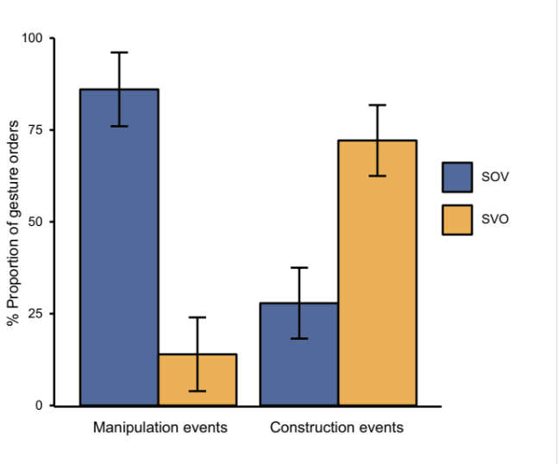
Figure 1: This is a figure.

Discussion
The discussion will often start with a brief summary of the results but in prose (no numbers). Then follows an interpretation connecting the findings to the hypotheses (were they confirmed or rejected? Why/why not?) and the relevant literature. In some sense, the discussion often makes the opposite movement than the introduction: i.e. it starts with the local, concrete observations and then relate that to the literature and eventually to the overall theoretical field of inquiry. Also, often the discussion will comment on limitations and/or possible confounding factors in the experiment and might touch upon prospects for further research.
Again, the discussion can be one continuous, uninterrupted section, but it is also often divided into shorter sections with subheadings.

Conclusions
Sometimes there will be a separate short conclusion section but this is not mandatory.

Acknowledgments
If you need to acknowledge someone, place such acknowledgments in a section at the end of the paper just before the references.

References
Follow the APA Publication Manual for citation format, both within the text and in the reference list.
Alphabetize references by the surnames of the authors, with single-author entries preceding multiple-author entries. Order references by the same authors by the year of publication, with the earliest reference first.
Example:

Chalnick, A., & Billman, D. (1988). Unsupervised learning of correlational structure. Proceedings of the Tenth Annual Conference of the Cognitive Science Society (pp. 510-516). Hillsdale, NJ: Lawrence Erlbaum Associates.
Hill, J. A. C. (1983). A computational model of language acquisition in the two-year old. Cognition and Brain Theory, 6, 287-317.
Ohlsson, S., & Langley, P. (1985). Identifying solution paths in cognitive diagnosis (Tech. Rep. CMU-RI-TR-85-2). Pittsburgh, PA: Carnegie Mellon University, The Robotics Institute.
Lewis, C. (1978). Production system models of practice effects. Doctoral dissertation, Department of Psychology, University of Michigan, Ann Arbor.
Newell, A., & Simon, H. A. (1972). Human problem solving. Englewood Cliffs, NJ: Prentice-Hall.
Shrager, J., & Langley, P. (Eds.) (1990). Computational models of scientific discovery and theory formation. San Mateo, CA: Morgan Kaufmann.

Sample of the first footnote
Sample of the second footnote

